Project Title

Automated Network Request Management in ServiceNow

Name : Mummalaneni Nithin Kumar.

College : KKR & KSR Institute of Technology and Sciences.

Email :23jr1a4496@kitsguntur.ac.in

Project overview
The Automated Network Request Management in ServiceNow project focuses on simplifying and accelerating the handling of network-related service requests. By leveraging ServiceNow’s service catalog, workflows, and automation capabilities, the solution eliminates manual bottlenecks and ensures requests are processed efficiently. End users can easily submit requests through a self-service portal,
while automated routing, approvals, and task assignments streamline fulfillment. Where possible, integration with network automation tools enables end-to-end execution without human intervention. This results in faster turnaround, improved SLA compliance, and enhanced transparency for both users and IT teams.

Table of Contents

- Introduction
- Project Objectives
- Key Features
- ServiceNow Developer Setup
- Project Implementation in ServiceNow
- Screenshots of Output
- Conclusion

Introduction

Modern enterprises rely heavily on robust and efficient network services to support day-to-day business operations. As organizations grow, the demand for network-related requests—such as access provisioning, configuration changes, and connectivity support—also increases. Traditional manual request handling often leads to delays, errors, and limited visibility, impacting both productivity and user satisfaction.
To address these challenges, the Automated Network Request Management in ServiceNow project introduces

a streamlined solution that leverages ServiceNow’s workflow engine, service catalog, and automation features. By enabling end users to submit requests through a self-service portal and automating approvals, task assignments, and notifications, the system ensures faster, more accurate, and transparent request management.
This initiative not only enhances the user experience but also empowers IT teams by reducing repetitive tasks, improving SLA compliance, and allowing focus on strategic, high-value activities.

Project Objective
This project aims to design and implement a streamlined, automated solution for managing network-related service requests within ServiceNow. It enables end users to submit requests for network services through a user-friendly self-service portal.
The system leverages ServiceNow’s workflow engine, catalog items, and approval processes to ensure requests are properly captured, validated, and routed for fulfillment. Upon submission, requests trigger automated notifications, task assignments, and—where applicable—integration with network automation tools or scripts to fulfill standard requests without manual intervention.

Key Features
  - Custom service catalog for common network requests
  - Dynamic forms to capture relevant request details
  - Automated approval workflows based on request type and sensitivity
  - Integration with infrastructure management or orchestration tools (optional)
  - Real-time status updates and notifications to requesters and technicians
Reporting and analytics on request volume, resolution time, and SLA adherence

ServiceNow Developer Setup:

Create a Developer Account
- Go to ServiceNow Developer Portal(https://developer.servicenow.com/dev.do).
Sign up for a free developer account and fill out the following details.

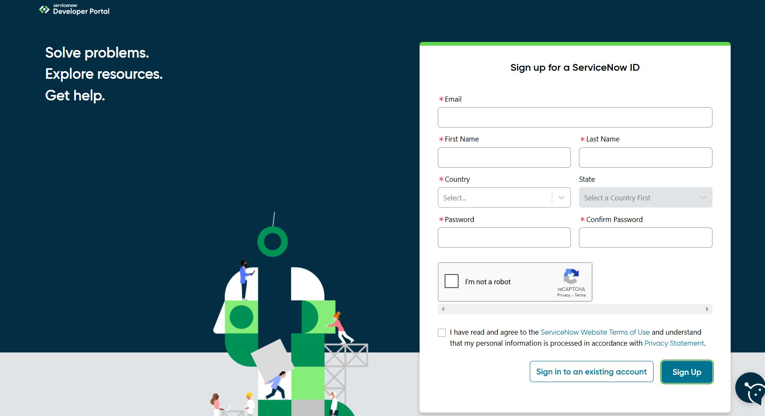
.

- After signing up, you will get a verification mail to your provided email id. After the verification your ServiceNow Developer Portal Home Page will appear.
- Now click on start building it will take you to the section where you can request a Personal
Developer Instance (PDI) or start using App Engine Studio and other tools.
- Profile Icon (Top Right Corner) → Manage your account, request instances, and check your developer profile.
- 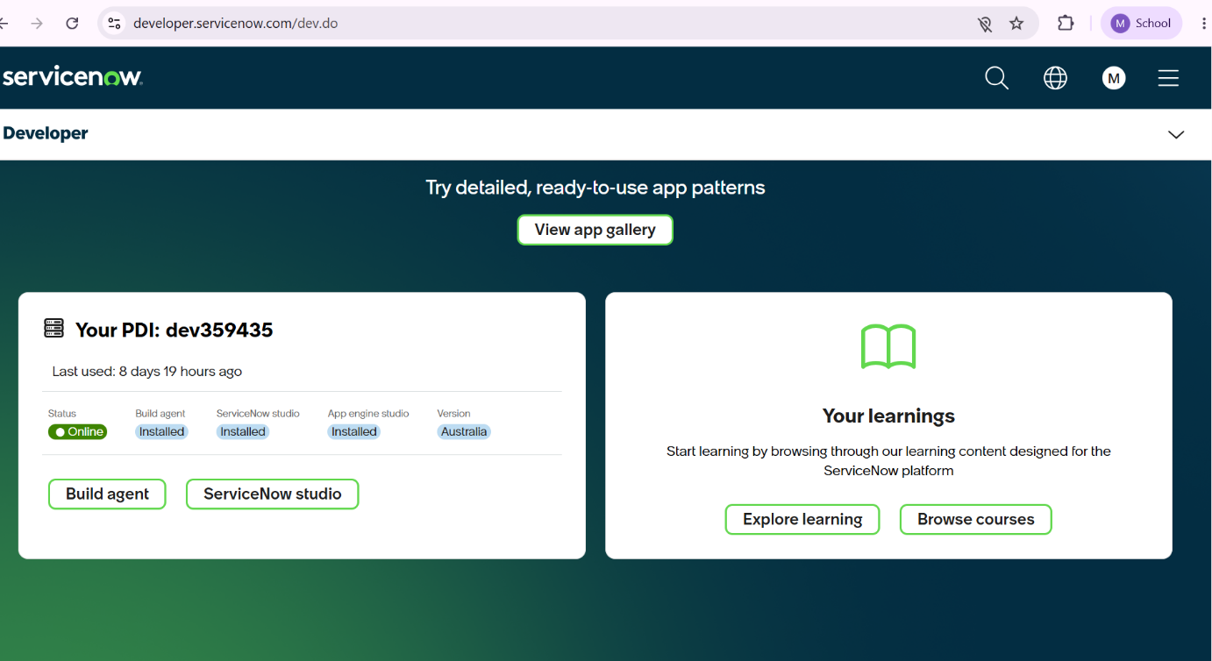

Project Implementation in ServiceNow:
After the instance building is completed, the page will be directed to your creator studio.

Creator Studio in ServiceNow provides a guided, no-code environment to build applications quickly. It is especially useful for creating request-based applications by defining forms, setting up tables, and automating workflows.
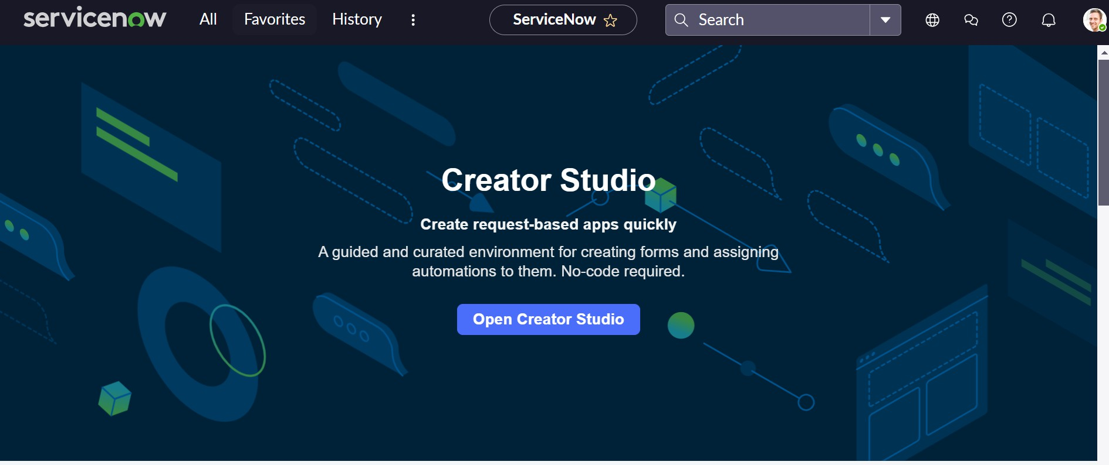

Service Catalog Creation

Creation of Service Catalog

    - Navigate to Application navigator
    - Click on All >> search for Service Catalog
    - Under Service Catalog>> Maintain items
    - Click on New
    - Fill the details >> Name– Network Request
    - Select Catalog>> Service Catalog
    - Select Category>> Network
    - Fill the Short Description as Network request Management
    - Click on Save.

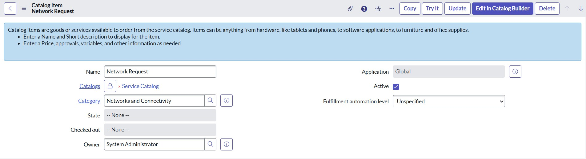

Variables Configuration
Open the catalog item just created.
Scroll down to the Variables related list and click New to create form fields.
    - Select Variables type as Single, Multi line text, reference, choices etc as per requirement
    - Catalog item– Network Request
    - Order–100,200,300,,,,
    - Question– provide the variable label
    - Name–provide the variables name(used for scripting)
    - Tooltip– this will appear when cursor overed on the field
    - Example text – this will suggest what we need to enter on the field.
    - Mandatory, Read-Only– need to configure on demand.
    - Auto populate– need to select dependent variable, apply dot walking to get selected value.
    - Click on Save or Submit.

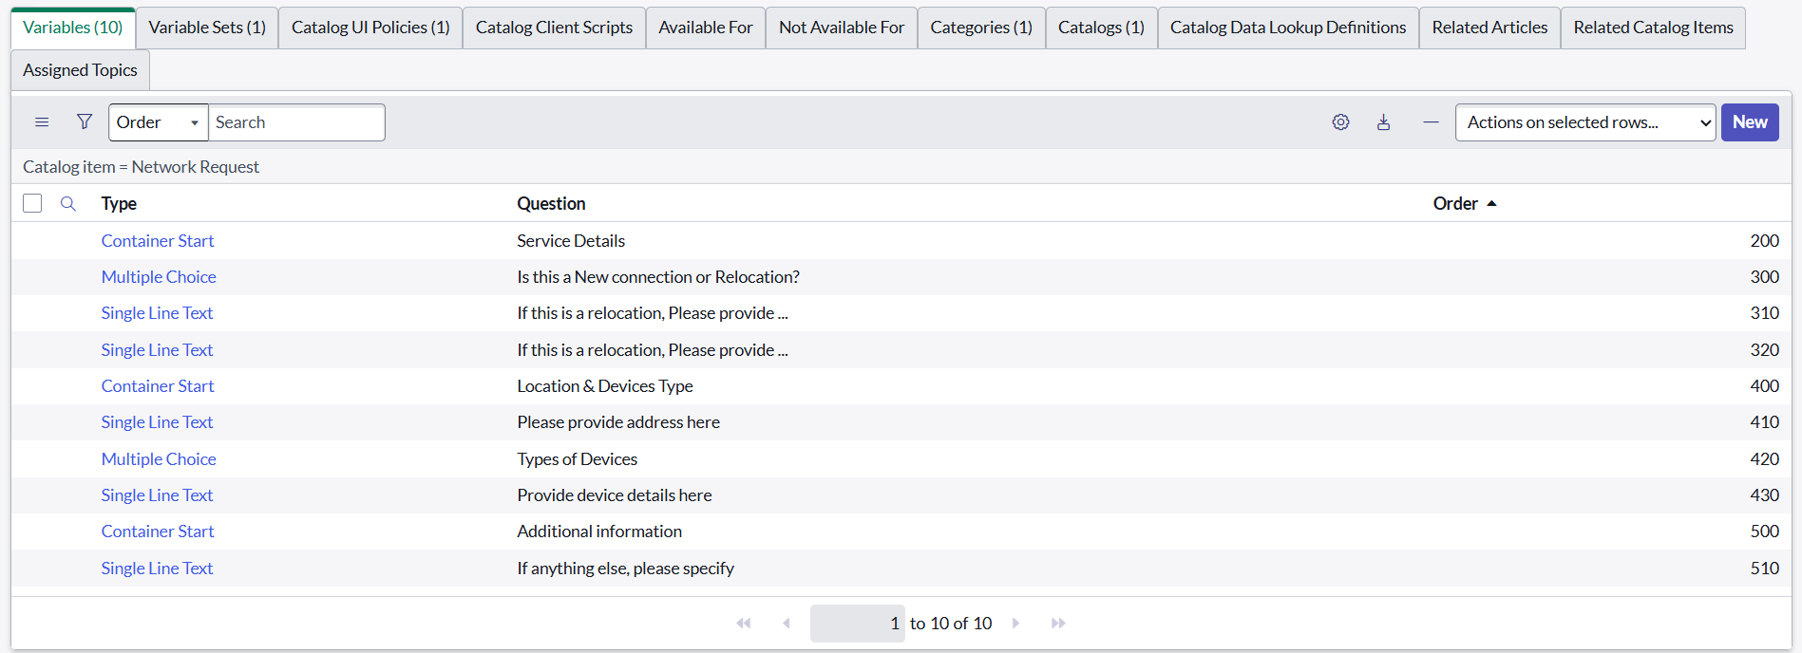

Variables Types
    - Is this a New connection or Relocation? >> Choice >> New/ Relocation/None
    - If this is a relocation, Please provide your relocated address here>>String
    - Types of devices>> Choice>> Laptop/Mobiles/Others
    - Please provide address here>>String
    - Provide device details here>> String
    - If anything else, please specify>> String

Variable Set Configuration
To enhance form usability:
- Navigate to the Variable Sets (optional).
- Follow the same procedure as we used for Variables Creation, for the variable set as well.
- Apply variable sets to the catalog item.
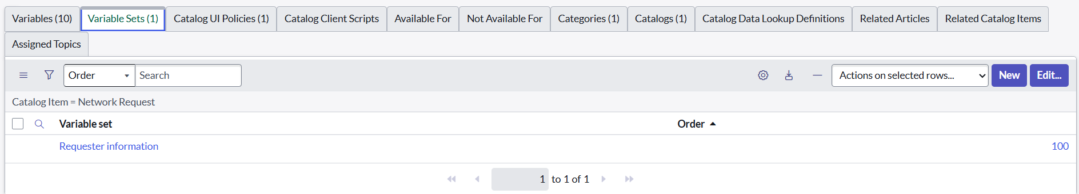

Variables Types

    - Opened on behalf of >> Reference>> reference to user table
    - Email Id >> Single line text >> Auto populate by Opened on behalf of variable.
    - User name >>Single line text >> Auto populate by Opened on behalf of variable.
    - Phone Number >>Single line text >> Auto populate by Opened on behalf of variable.
    - Proof of Document >> Attachment
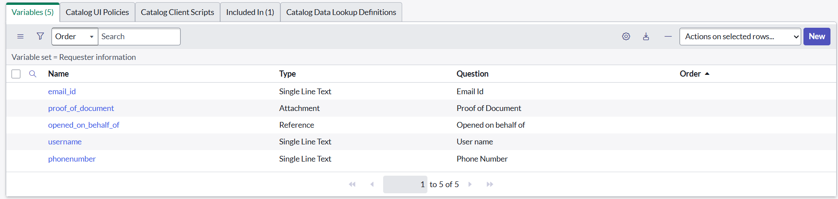

Catalog UI Policy Configuration

Scenario: If user selects types of devices is Others, then Please specify field should populate.

Procedure:

    - Navigate to catalog items
    - Open Network Request item
    - In related list, we have Catalog UI policy
    - Click on New button to configure New UI policy
    - Select Applies to as Catalog item
    - Select catalog item as Network Request
    - Provide short description, if required
    - Apply condition>> types of devices is others
    - Click on save, after saving the form will get UI policy actions in the related list

    - Click on New button to configure new UI Policy action, and Select the variable which we want to display on condition
    - Make Visible True as per our requirement
    - Update the UI Policy and Test the same on Catalog form
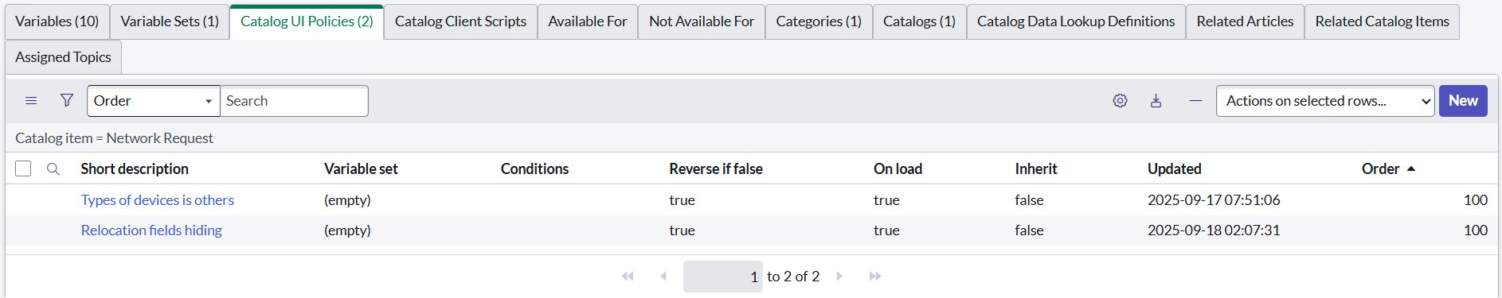

Creation of Table

Creation of Table

    - Navigate to: System Definition > Tables.
      - Click New to create a new table.
      - Fill in Table Information:
        - Name: Name of the table ------
        - Label: Backend name of the table------
        - Auto-generate schema: Leave it checked if you'd like ServiceNow to auto-generate schema fields.
      - Click Submit to create the table.
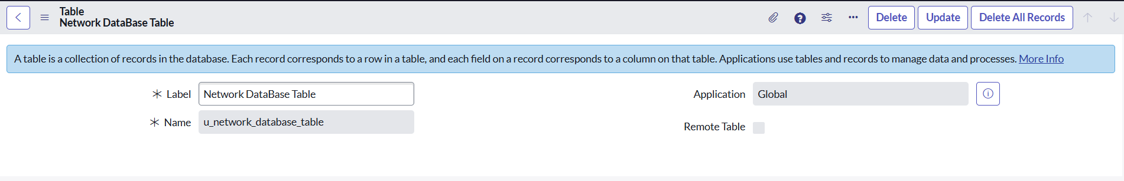

Creation of fields

In ServiceNow, fields are created at the table level. To create a field, you first need to identify the table where the field will reside.
    - In the Application Navigator (left-side panel), type Tables in the search bar.

    - Under System Definition, click Tables. This will take you to a list of all tables in the system.

Select the Table to Add the Field

From the list of tables, search for and select the table you want to add a field to. For example, if you want to add a field to the Network database table:
  - Type "Network database" in the search box or scroll through the list.

  - Click on the Network database table name. You’ll now see a list of all fields (columns) associated with the Network database table.

Open the Table's Columns

· After selecting the table, you'll be brought to a view that lists all the columns (fields) that currently exist on that table.
To create a new field (column), go to the Columns tab (this is where all fields for the selected table are listed).

Create a New Field

  - In the Columns tab, click the New button located at the top-right corner of the page to create a new field.
  - You’ll now be prompted with a form where you need to define the new field. The following fields need to be filled out:

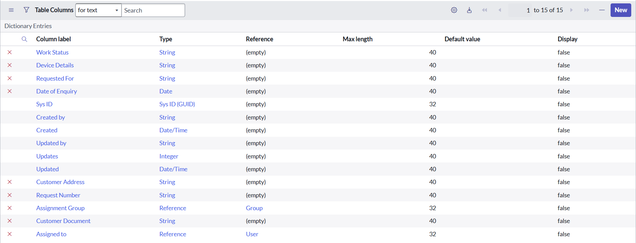

Request Approvals Creation(Related List)

Creation of Related List

    - Navigate to System Definition > Relationships.
    - Click New to create a new relationship.
    - Fill in the following details:
- Name: Approval Request
- Applies to Table : Network Database table.
- Queries from Table : Sysapprovals table.
- Active: Make sure it's set to True.
    - Save the relationship.
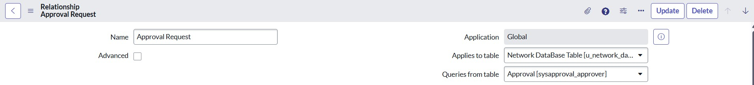

Adding Related List to the Table

    - Navigate to Form Designer for the table where you want to show related records.
    - Add a Related List widget to the form.
    - Select the Related List you want to show

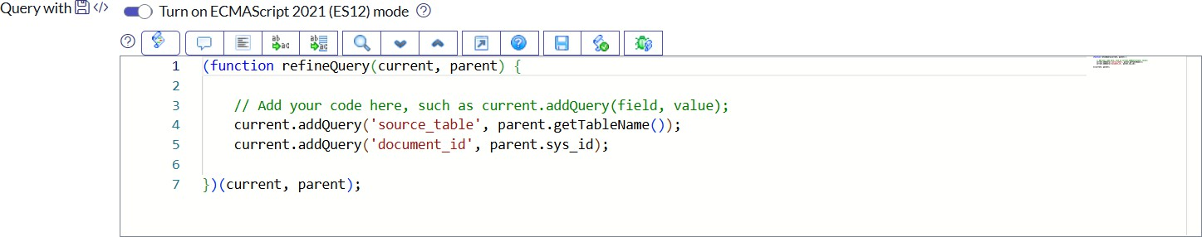

Creation & Implementation of flows, Actions in Flow Designer
  - Creation of Flow
    - Navigate to Flow designer home page
    - Click on New to create a new flow
    - Provide flow name as Network Request
    - Provide description of flow
    - Click on Build flow.

Configuring Trigger
    - Click on (+) Icon to Configure the Trigger
    - Select Trigger as Application >> Service catalog
    - Click on Done.
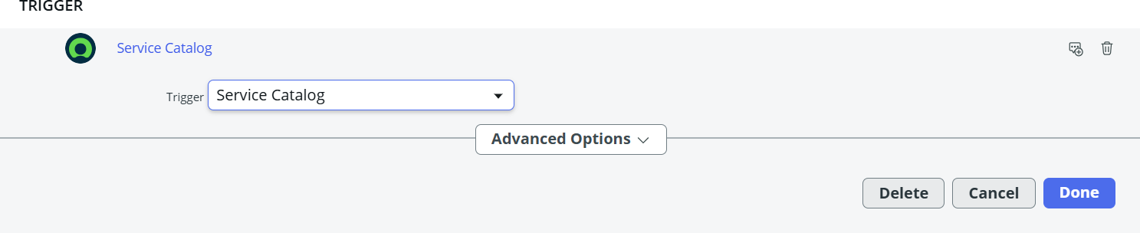

Configuring Actions
Click on Actions button to configure new action

Get Catalog Variables
- Click on Action, search for Get Catalog Variables
- Select Get Catalog Variables
- Action Inputs>> Trigger>>service catalog>>Requested Item
- Template catalog items >> Select table >> Network Request

- Select the Required Variables and Move to the selected area.
- Click on done
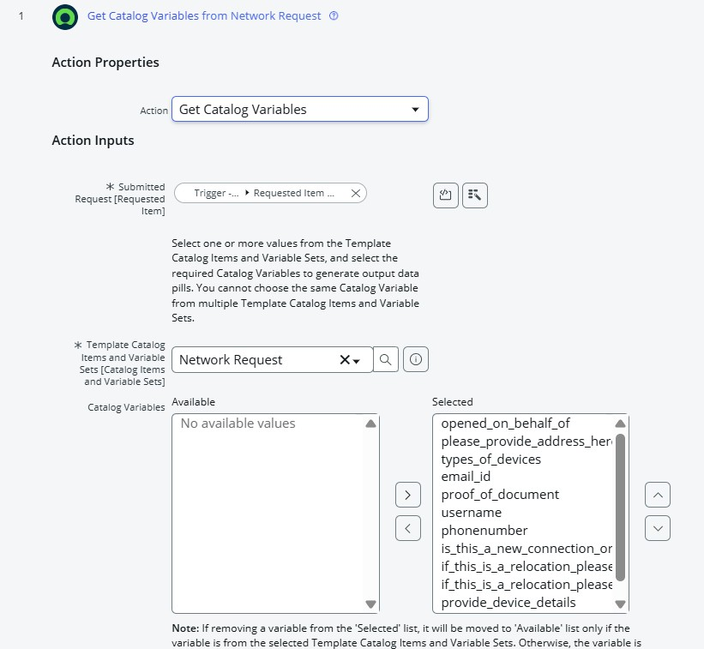

Create Record
- Select action as Create Record
- Select table as Network Database
- Click on Add fields button to configure the fields
- Configure the Required fields as shown in the below picture
- Click on done

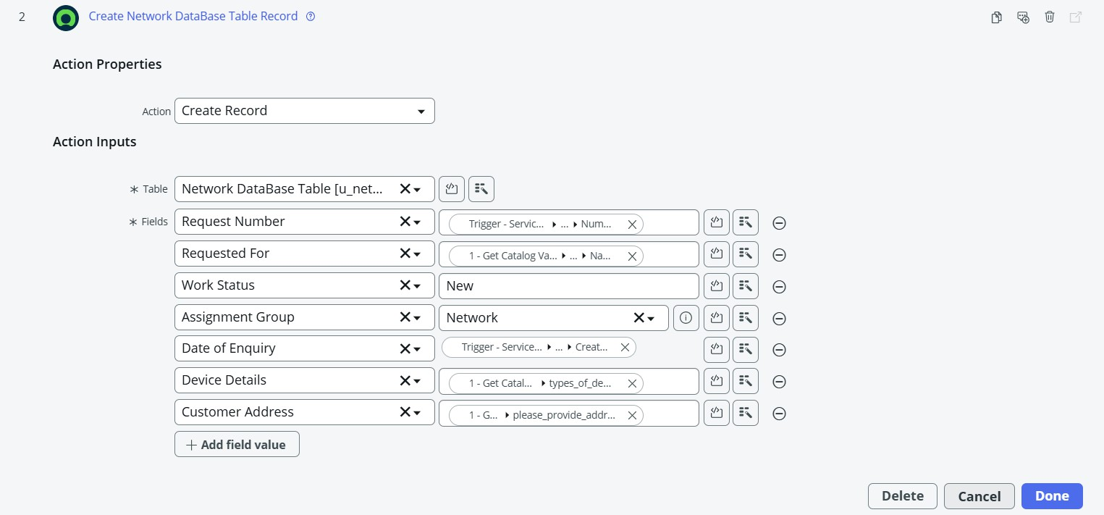

Ask for approvals
  - Select action as Ask for Approval
  - Select target record >> Create record>> network database table
  - Provide Approval Reason>> Waiting for approval
  - Configure approval rules>> Approve, reject, approve/reject
  - Select approvals as Anyone approves, everyone approves etc.
  - We can select approvals like static/dynamic as shown below
  - Click on done
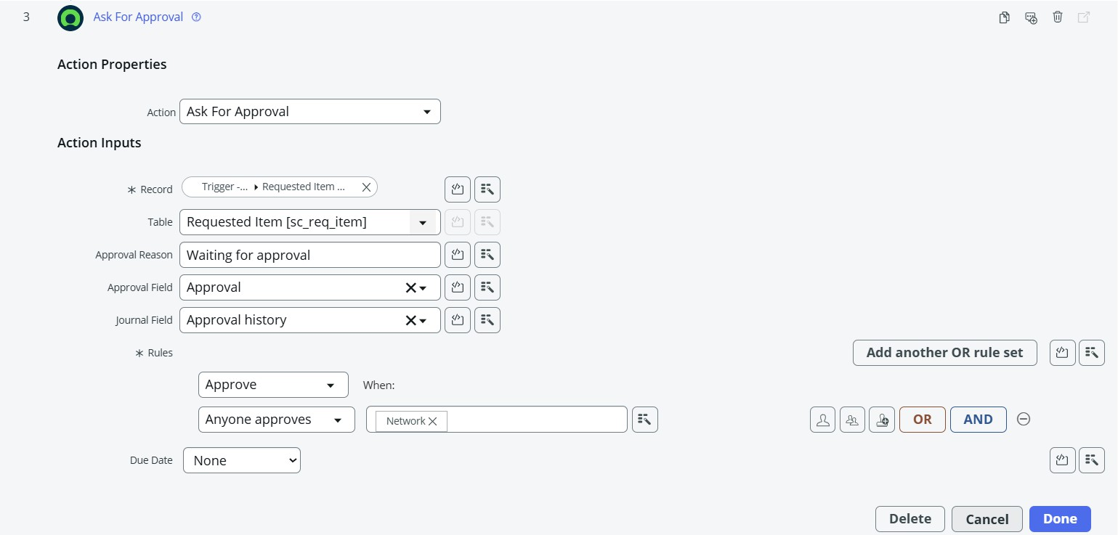

Flow Logic
  - Select action as flow logic and Select If condition
  - Apply condition >> Ask for approvals state is Approved/Rejected as per requirement
  - Click on done
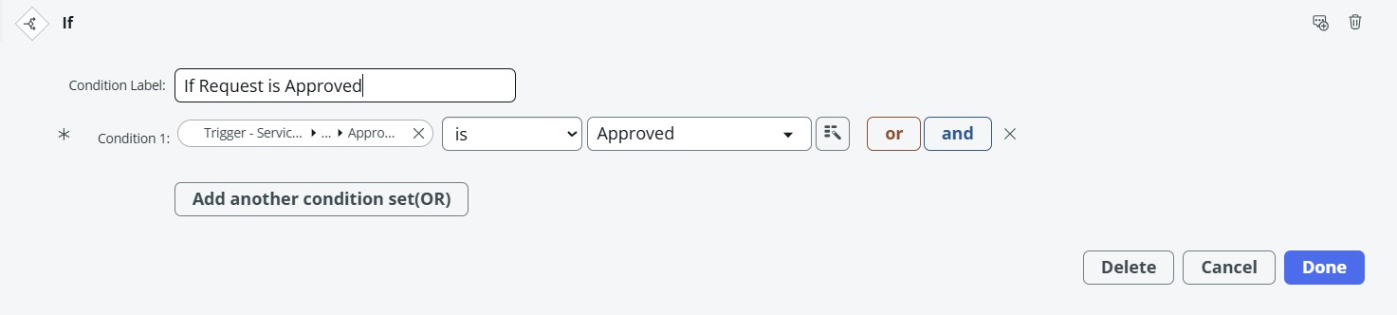

Send Email
  - Select action as Send Email
  - Select target record >> Create record>> network database table
  - Table will be selected automatically
  - Cofigure To, CC, BCC as per our requirements(select static/dynamic)
  - Provide Subject & Body as shown in the below picture
  - Click on done
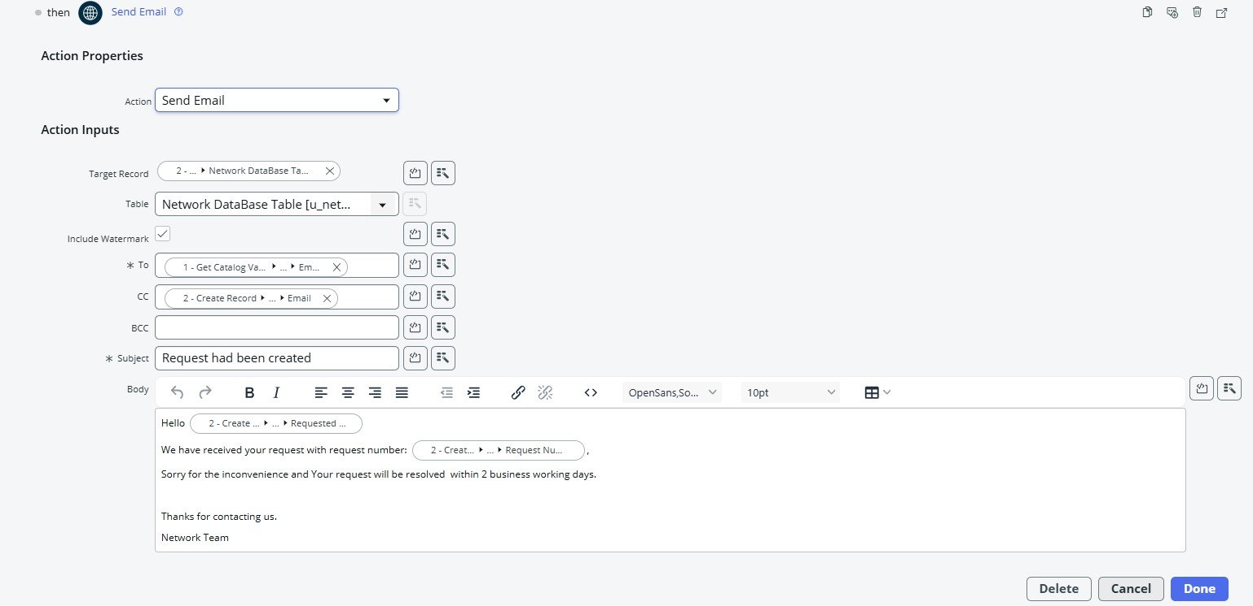

Update Record
  - Select action as Update Record

  - Select record as >> create record>> network database
  - Table will be selected automatically
  - Configure the fields as per requirement, as shown in below
  - Click on done
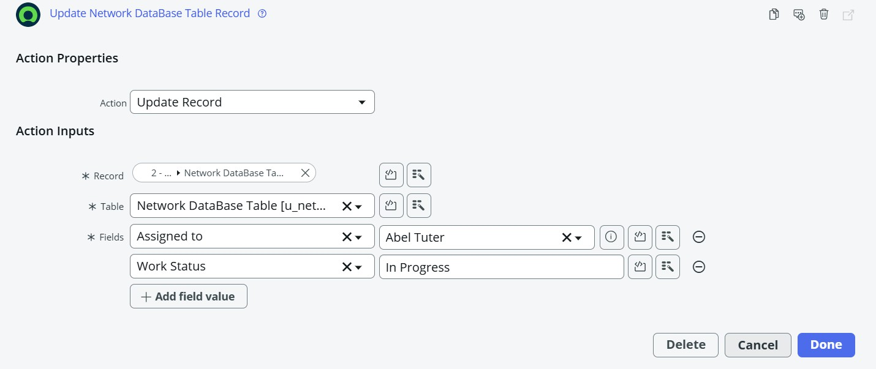

Flow Chart
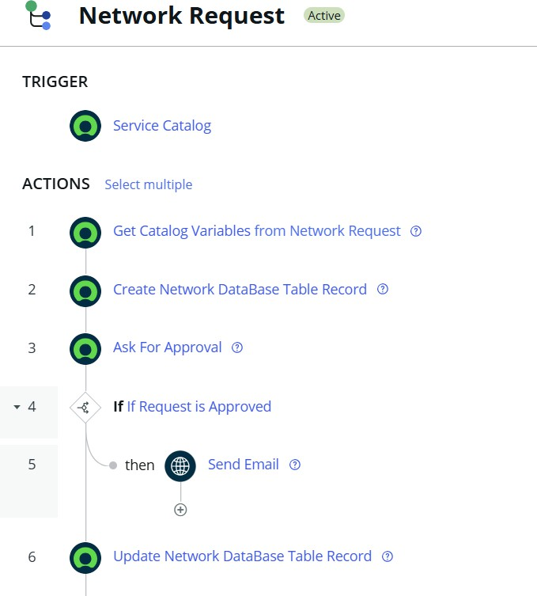

Screenshots of Output
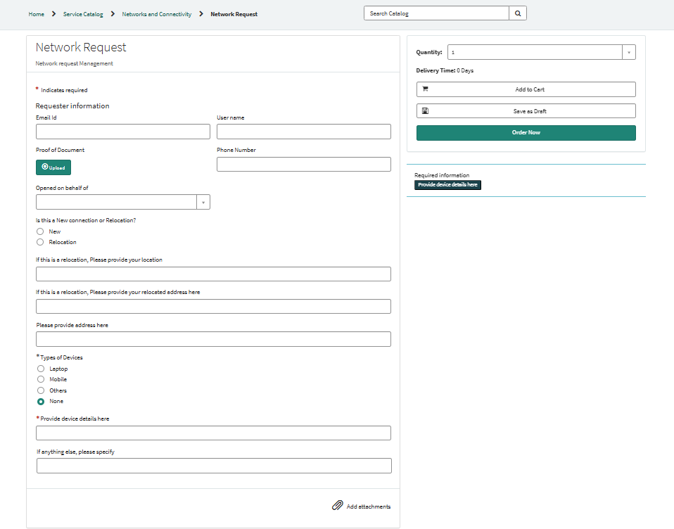

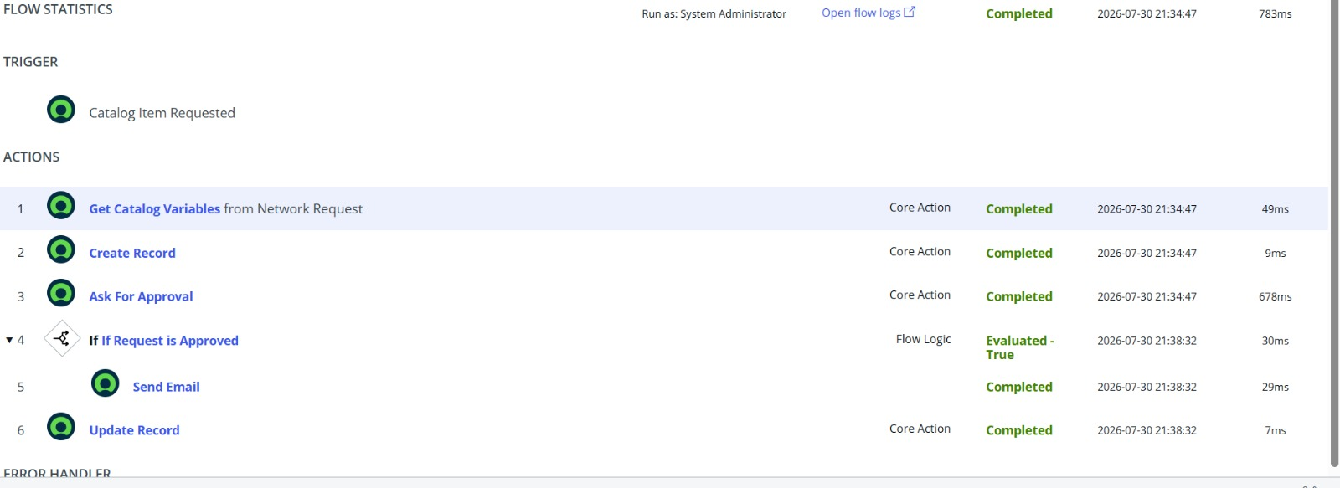

fig : Test for flow execution

Conclusion
The Automated Network Request Management in ServiceNow project provides a streamlined, reliable, and user-friendly solution for handling network-related service requests. By automating approvals, routing, and notifications, the system eliminates delays and errors associated with manual processes while offering transparency through real-time updates and reporting.
This initiative not only improves SLA compliance and user satisfaction but also optimizes IT operations by reducing repetitive workload and enabling faster fulfillment. Ultimately, it supports the organization’s goal of delivering efficient, high-quality, and responsive network services, empowering both end users and IT teams.

